Name:  Class: | ____________________________________  ________________ |  | Date: _________
 | Year 7 Mathematics  Mini-Test 2, 2018  Topic – Volume and Algebra |  | / 24  %
Total Time: | 30 min
Weighting: | 8 %
Equipment: | Calculator and 1 page of notes A4 (one sided). *SHOW ALL WORKING OUT*

A Grade
Represents numbers using variables and writes multiple algebraic expressions to represent unfamiliar concrete and authentic situations.
Identifies and justifies equivalent forms by substitution and applying the laws and properties of arithmetic to algebraic expressions.
Distinguishes between linear, area and volume units when expressing solutions to most measurement problems.
Calculates, compares and justifies the volume of rectangular prisms, including those with dimensions in different and part units, using concrete material and diagrams.
B Grade
Represents numbers using variables and writes multiple algebraic expressions to represent familiar concrete and authentic situations.
Identifies and justifies equivalent forms by substitution and applying the laws and properties of arithmetic to algebraic expressions.
Calculates and justifies the volume of a rectangular prism, including those with dimensions in different and part units, using concrete materials and diagrams. Uses correct units for the context.
Distinguishes between linear, area and volume units sometimes, when expressing solutions to some measurement problems
C Grade
Represents numbers using variables and writes algebraic expressions to represent simple concrete and authentic situations.
Applies the laws and properties of numbers to variables in simple situations.
Calculates and justifies the volume of a rectangular prism using concrete material and diagrams.
Uses linear units when expressing solutions in most measurement problems.
D Grade
With prompting, represents a number using a variable and writes algebraic expressions to represent simple concrete situations.
With prompting, recognises and/or applies the laws and properties of numbers to variables.
Calculates and justifies the volume of a rectangular prism using concrete material.
Expresses solutions to simple measurement problems without including units.
E Grade
Does not meet the requirements of a D grade.

Teacher Feedback:

Question 1 [4 marks]
Your teacher will come around with some blocks in a box. You are to make a rectangular prism using less than 20 blocks. Include the following:

Length = | Width = | Height = | Volume =

Question 2 [3 marks]
- Simon has (g) fish in his aquarium. Define what (g) is.

- He buys 10 more fish. Write an expression to show how many fish he has now.

- If Simon originally had 16 fish in his aquarium, how many fish will be in the tank now?

Question 3 [3 marks]
- Sally has cookies in her lunchbox. Determine the variable and define what it is.

- Sally buy 5 more cookies and gives half of all her cookies to her brother. Write an expression to show how many cookies she has.

- If Sally started off with 10 cookies in her lunch box, how many cookies will she be left with?

Question 4 [4 marks]
Using substitution, evaluate the following expressions:

p = 3 | t = 25 | b = 8 | y = 12
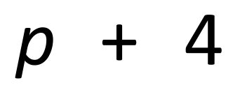 | 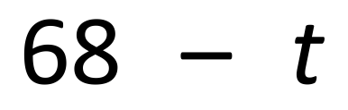 | 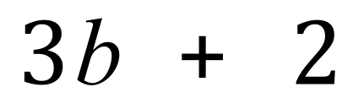 | 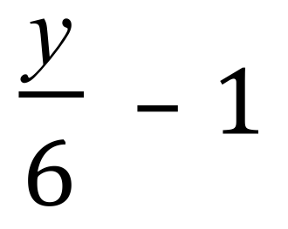

Question 6 [4 marks]
Find the volume for the following shapes:
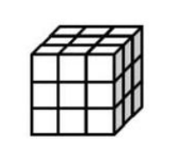 | 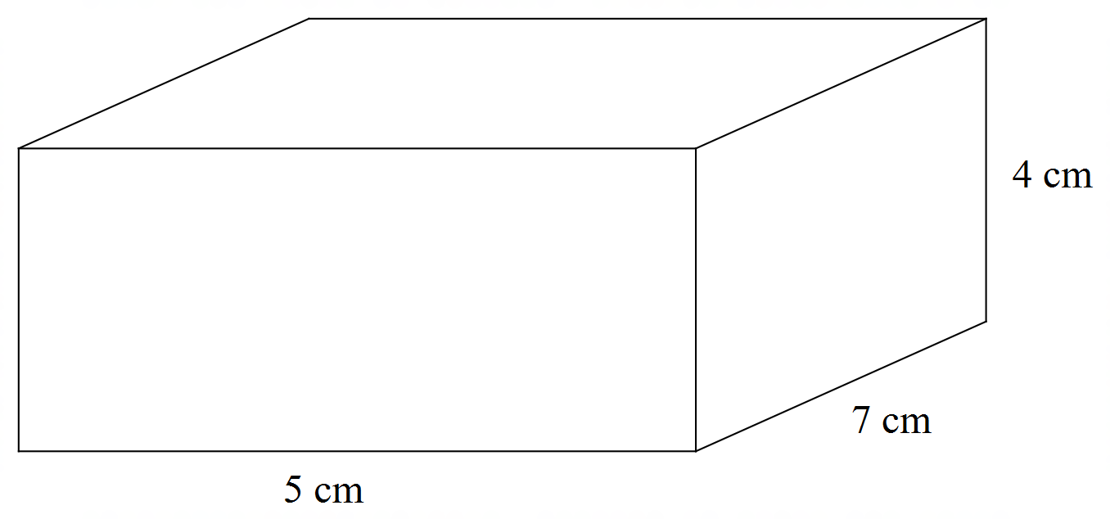
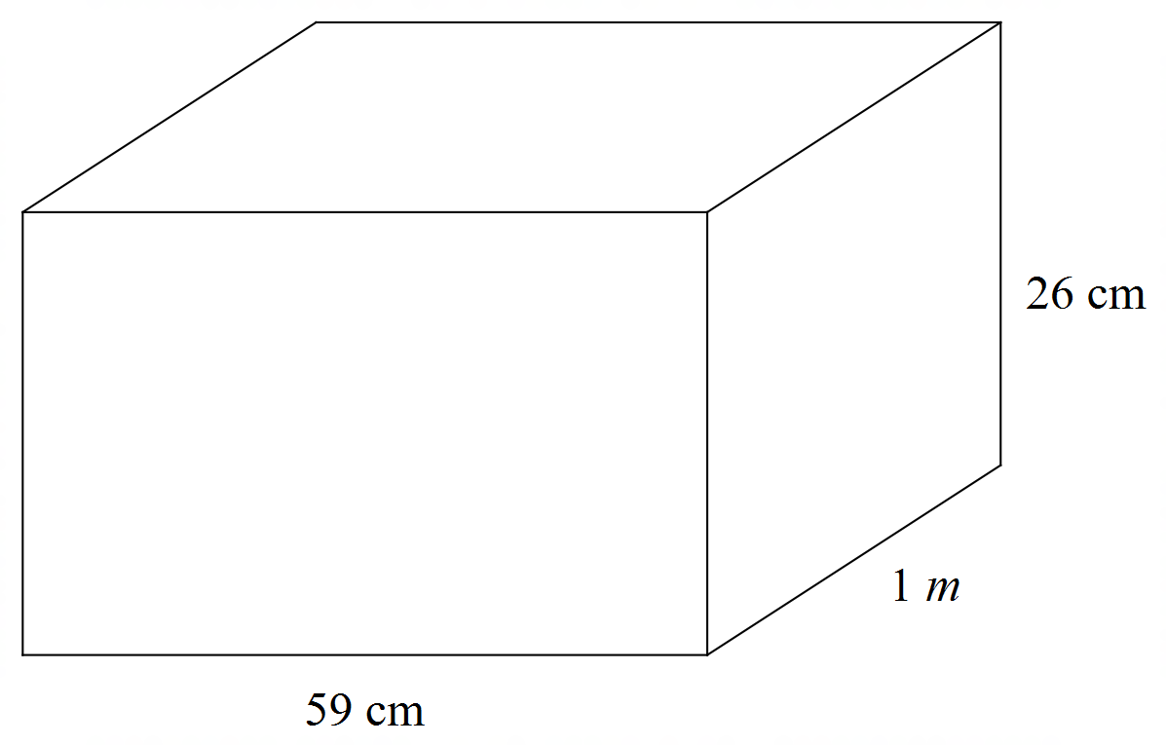

Question 7 [6 marks]
Each box has p number of marbles in them.
Each bag has w number of marbles in them.
There are 4 loose marbles.

Find five different ways to express the number of marbles in the picture.
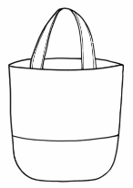
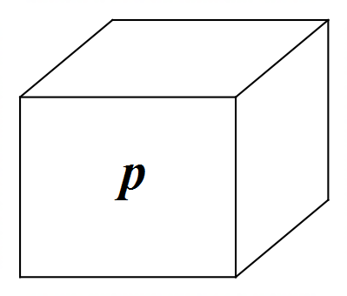
w
w
w
w



Expression 1 ________________________

Expression 2 ________________________

Expression 3 ________________________

Expression 4 ________________________

Expression 5 ________________________

